

***Entity Framework***

**Lab Guides**

|  |  |
| --- | --- |
| Document Code | 25e-BM/HR/HDCV/FSOFT |
| Version | 1.1 |
| Effective Date | 20/11/2012 |

**Hanoi, 07/2019**

RECORD OF CHANGES

|  |  |  |  |  |  |
| --- | --- | --- | --- | --- | --- |
| No | Effective Date | Change Description | Reason | Reviewer | Approver |
|  | 01/Oct/2018 | TuTB create new | Draft |  |  |
|  |  |  |  |  |  |
|  |  |  |  |  |  |
|  |  |  |  |  |  |
|  |  |  |  |  |  |
|  |  |  |  |  |  |
|  |  |  |  |  |  |
|  |  |  |  |  |  |
|  |  |  |  |  |  |
|  |  |  |  |  |  |

Contents

Lab: Configure Many-to-Many Relationships 4

Objectives: 4

Prerequisites: 4

Problem Description: 4

Guidelines: 4

Step 1: Open Visual Studio and create a console project 4

Step 2: Check .net Framework version 4

Step 3: Add **Student** model 4

Step 4: Add **Course** model 5

Step 5: Create context 5

Step 6: Configure a Many-to-Many Relationship 5

|  |  |
| --- | --- |
|  | **CODE: NEFW.S.L004**  **TYPE: SHORT**  **LOC: 120**  **DURATION: 30 MINUTES** |

# Lab: Configure Many-to-Many Relationships

Objectives:

* Learn how to configure a Many-to-Many relationship.

Prerequisites:

* Download and installs Visual Studio (included .net Framework).

Problem Description:

* EF 6 includes default conventions for many-to-many relationships. You need to include a collection navigation property at both ends. For example, the Student class should have a collection navigation property of Course type, and the Course class should have a collection navigation property of Student type to create a many-to-many relationship between them without any configuration.

Guidelines:

### Step 1: Open Visual Studio and create a console project

### Step 2: Check .net Framework version

### Step 3: Add **Student** model

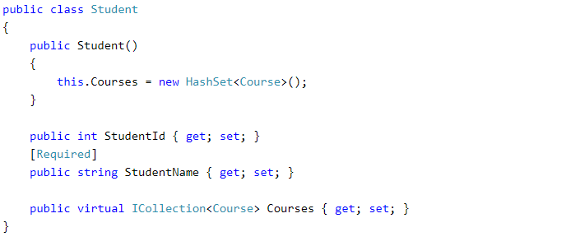

### Step 4: Add **Course** model

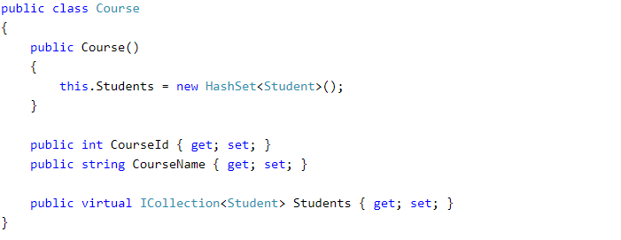

### Step 5: Create context

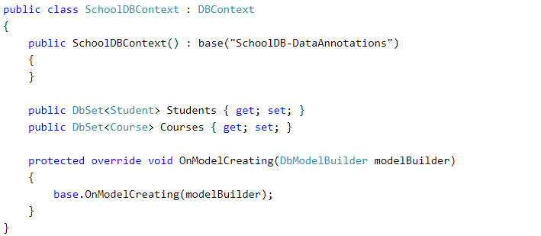

### Step 6: Configure a Many-to-Many Relationship

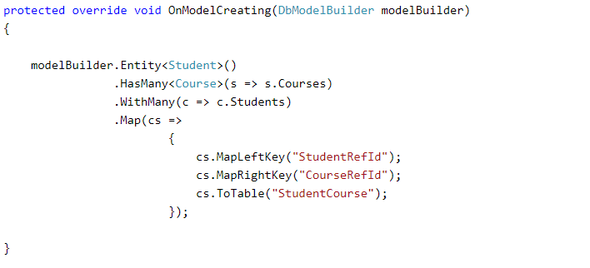

Step 7: Check result

